

Hudson Technologies Inc. NasdaqCM:HDSN
FQ3 2019 Earnings Call Transcripts
Thursday, November 14, 2019 10:00 PM GMT
S&P Global Market Intelligence Estimates
 | -FQ3 2019- |  |  | -FQ4 2019- | -FY 2019- | -FY 2020-
 | CONSENSUS | ACTUAL | SURPRISE | CONSENSUS | CONSENSUS | CONSENSUS
EPS Normalized | (0.06) | 0.06 | NM | (0.11) | (0.59) | -
Revenue (mm) | 45.95 | 45.63 | (0.70 %) | 26.60 | 163.24 | 185.08
Currency: USD
Consensus as of Aug-16-2019 2:22 PM GMT

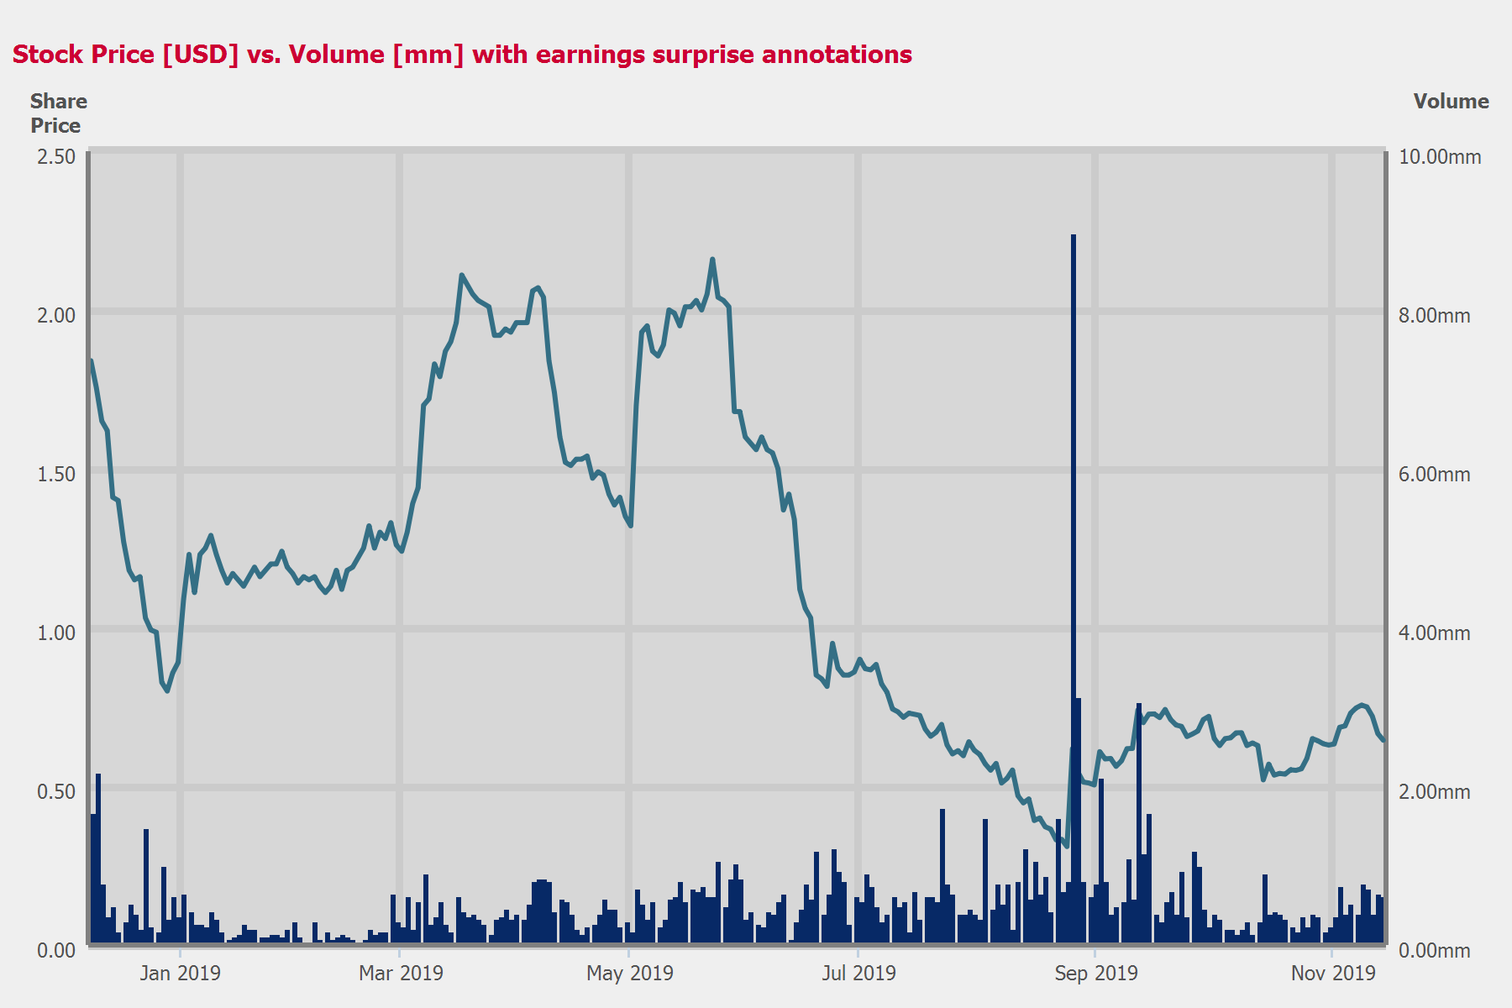
 |  |  |  | - EPS NORMALIZED -
 | CONSENSUS |  | ACTUAL |  | SURPRISE
FQ4 2018 | (0.16) |  | 0.08 |  | NM
FQ1 2019 | (0.09) |  | (0.09) |  | NM
FQ2 2019 | (0.01) |  | (0.32) |  | NM
FQ3 2019 | (0.06) |  | 0.06 |  | NM

Table of Contents

Call Participants | ........................................................................................................................................................ | 3
Presentation | ........................................................................................................................................................ | 4
Question and Answer | ........................................................................................................................................................ | 7

Call Participants
EXECUTIVES
Brian F. Coleman
President, COO & Director
Kevin J. Zugibe
Founder, Chairman of the Board & CEO
ANALYSTS
Ryan Ronald Sigdahl
Craig-Hallum Capital Group LLC, Research Division
Unknown Analyst
ATTENDEES
Jennifer Belodeau
Institutional Marketing Services, Inc.

Presentation
Operator
Greetings, and welcome to the Hudson Technologies Third Quarter 2019 Earnings Conference Call. [Operator Instructions] As a reminder, this conference is being recorded.
It is now my pleasure to introduce your host, Jen Belodeau. Thank you. you may begin.
Jennifer Belodeau
Institutional Marketing Services, Inc.
Thank you. Good evening, and welcome to our conference call to discuss Hudson Technologies financial results for the third quarter of 2019. On the call today, we have Ken Zugibe, Chairman and Chief Executive Officer; and Brian Coleman, President and Chief Operating Officer.
I'll now take a moment to read the safe harbor statement. During the course of this conference call, we will make certain forward-looking statements. All statements that address expectations, opinions or predictions about the future are forward-looking statements. Although they reflect our current expectations and are based on our best view of the industry and of our businesses as we see them today, they are not guarantees of future performance. Please understand that these statements and all the number of risks and assumptions, and since those elements can change, and in certain cases, are not within our control, we would ask that you consider and interpret them in that light.
We urge you to review Hudson's Form 10-K and other SEC filings for a discussion of the principal risks and uncertainties that affect our business and our performance and of the factors that could cause our actual results to differ materially.
With that, I'll turn the call over to Kevin. Go ahead, Kevin.
Kevin J. Zugibe
Founder, Chairman of the Board & CEO
Good evening, and thank you for joining us. Despite the continuing challenging -- challenges our industry is facing, we closed out 2019 selling season with solid third quarter revenue growth, driven by an increase in volume of certain refrigerants sold and growth within our DLA contract. Pricing remained at levels consistent with what we saw at the end of the second quarter, but were lower when compared to pricing in the third quarter of 2018.
During the third quarter, R-22 pricing was approximately $9 per pound. Recently, the remaining 2 large allocation holders have raised R-22 prices, and we are currently experiencing pricing above $10 per pound, which is the first time that we have seen sales up at this price level this year.
Although R-22 pricing during this year's sales season was disappointing, we're encouraged that our volume has increased, and we're experiencing the first upward trend in pricing in quite a while.
Additionally, now that one of the big 3 producers has announced that it is no longer supporting R-22 sales, looking forward, we are optimistic about pricing and demand for R-22 in the 2020 sales season.
There remains a large installed base of R-22 systems in the U.S. Demand for comfort cooling and food refrigeration is strong and continues to grow. And given the expense associated with replacing or upgrading a refrigeration or cooling system, we expect demand for R-22 to continue through 2030 and beyond.
With the elimination of virgin production and importation in 2020, we expect to see a shortfall in the supply of R-22, and we believe our ability to reclaim and resell R-22 creates a tremendous opportunity to position Hudson to address the anticipated supply shortage and become the leading producer of R-22.
Beyond R-22, it is important to remember that Hudson is competitively positioned at 2 points in the supply chain with a strong national distribution network and the ability to provide all types of refrigerants anywhere in the country at any time. This includes legacy gases, such as CFCs, currently used gases including R-22 and HFCs as well as next-generation HFO products.
Additionally, the industry will likely continue to phase out HFC refrigerants as a development and use of more environmentally friendly products continues. We have the proprietary technology to evolve along with those changes and reclaim all of these gases more quickly and efficiently than any competitor, positioning us as a leading supplier and producer for the foreseeable future.
During the last 2 selling seasons, the entire industry saw a significant decline in pricing in almost all refrigerants. As we are steadily selling off our higher-cost FIFO layers, we've increased overall sales volume to our customers and have positioned the company to benefit from the eventual stabilization of our industry pricing dynamics.
2019 has been a challenging year, but as evidenced by our increased sales volume, we're confident about our long-range prospects, and we remain focused on growing our market share and leadership position.
Unfortunately, as of today, we remain noncompliant with the financial covenants contained in our term loan and our revolving credit facility. Brian will provide more detail around this situation. But in short, we don't believe that the covenant defaults relate to a liquidity issue, but rather relate to a leverage issue under the current covenant structure.
Our brands, ASPEN and Hudson are well-known and well-respected in the marketplace, and we have an established and growing customer base. Perhaps most importantly, we move forward with the knowledge and experience gained from our more than 30 years in business. Time and again, we have demonstrated our agility in the face of adverse market conditions, and we are intently focused on leveraging our competitive positioning in the supply chain, our enhanced portfolio of products, our technology and our large customer base to grow our market share and leadership position.
Now I'll turn the call over to Brian to review the financials. Go ahead, Brian.
Brian F. Coleman
President, COO & Director
Thank you, Kevin. For the third quarter ended September 30, 2019, Hudson recorded revenues of $45.6 million, a 13% increase compared to the $40.5 million in the comparable 2018 period. The increase in revenues was due to increase in refrigerant volumes and growth with the DLA contract, offset by a decline in prices of certain refrigerants sold during the 2019 quarter when compared to 2018.
SG&A expense for the third quarter of 2019 was $8.3 million, an increase of $900,000 from the $7.4 million in the third quarter of 2018. The increase in SG&A was primarily related to over $1 million of professional fees regarding activities with the lenders and insurance expense.
The net income for the third quarter of 2019 was $2.7 million or $0.06 per basic and diluted share. During the third quarter of 2019, as previously announced, we settled a working capital dispute with Airgas around Hudson's acquisition of ASPEN Refrigerants in the amount of $8.9 million.
Net loss for the third quarter of 2018 was $13.9 million or $0.33 per basic and diluted share. Included in the $13.9 million third quarter 2018 loss are approximately $9 million in noncash charges related to a deferred tax reserve and approximately $2 million in nonrecurring charges related to the acquisition and integration of ARI or ASPEN Refrigerants.
As Kevin mentioned earlier, the company failed to comply with financial covenants in our term loan and revolving credit facilities at September 30, 2019. We are currently in default under those agreements. Other than the financial covenants, the company has been fully compliant with all of its debt payments and other obligations on a timely basis and had over $23 million of availability pursuant to the borrowing base formula and its revolving credit facility as of September 30, 2019.
During the third quarter of 2019, the company utilized cash from operations to pay over $18 million of debt. As such, the company does not believe the covenant default relates to liquidity issue, but rather relates to a leverage issue on the current covenant structure. We are working closely with our lenders to secure waivers and amendments under both the term loan and revolving credit facility. The lenders do have the right to declare all amounts under these facilities to be immediately due and payable and there could be no assurances that the company will be able to attain any such waivers or amendments.
We were at a similar position last year with our lenders. And while there are no guarantees, we believe that the company, its advisers and the lenders and their advisers can reach an agreement on these matters.
I will now turn the call back over to Kevin.
Kevin J. Zugibe
Founder, Chairman of the Board & CEO
Thanks, Brian. We remain energized by long-term opportunity in front of us. And with our proven ability to evolve along with our industry, we believe we're well positioned to take advantage of the changing market dynamics. The refrigerant industry has long been a fluid marketplace and at Hudson, we have focused our efforts on ensuring that we have the right products, technology and people in place to capitalize on this dynamic environment and to expand our leadership role in the refrigerant reclamation business.
Thank you all for your continued support of Hudson. And now Brian, Nat and I will take your questions. Operator, please open the call to questions.

Question and Answer
Operator
[Operator Instructions] Your first question comes from Steve Dyer, Craig-Hallum.
Ryan Ronald Sigdahl
Craig-Hallum Capital Group LLC, Research Division
Ryan Sigdahl on for Steve. A few questions, I guess, on the recent price increase. What's been the market reaction to the raise? And then has that been across the whole industry? Did others follow suit behind kind of the large guys that did it first?
Kevin J. Zugibe
Founder, Chairman of the Board & CEO
I'd say a little bit of yes and no meaning, we're in the wintertime. So it's not the same as the middle of the season. So volumes, obviously, are nowhere near where they'd be in the summer. But that said, as we saw the prices come from the big guys, the reason we're able to get [ 10 ] is because others have followed suit. If we were -- if they stayed down there, we wouldn't be able to. So it doesn't mean that everyone in the chain has done that. There's some stragglers always. But across the board, we're seeing others, not just the main producers or the big allocation holders with higher prices. So we're not alone out there. But again, there could be a couple of stragglers.
Ryan Ronald Sigdahl
Craig-Hallum Capital Group LLC, Research Division
And then just one quick follow-up on that. I guess, is it primarily a function of kind of the supply-demand environment and getting closer to the 2020 full phase-out here? Or is it -- was it just trying to kind of push through a price just to test the market's reaction, I guess, in a seasonally slow time? So it seems like an odd time of the year to push through pricing, I guess. So any color, I guess, on what you're hearing on why they decided now?
Kevin J. Zugibe
Founder, Chairman of the Board & CEO
We've seen at times that producers, others raised price in Q4 as sort of a precursor to price increases that will happen in the following spring and so forth. We can't obviously predict that that's the action happening right now, but we have seen this happen before that it's setting the stage for further price increases. But we're assuming again that the genesis behind that is there's only a certain amount of supply that they would have in stockpile and they're limiting their supply, and that's what is -- the first is they would be limiting their supply, which would raise the price and follow -- the market would follow. So this was the first sign of some eliminating their supply by raising the price.
Ryan Ronald Sigdahl
Craig-Hallum Capital Group LLC, Research Division
Great. Then switching over. I mean, volume was up nicely in the quarter. Was that a function of you guys trying to push through some of that higher-priced inventory? Or was it a strength in the industry?
Kevin J. Zugibe
Founder, Chairman of the Board & CEO
It was more -- last year, we had a couple of cycles where we were not as competitive as we, let's say, in hindsight, ought to have been because there were price declines occurring that we thought were going to be temporary and it became more permanent. So throughout this entire year, we've been more aggressive or returning to more normal pricing practices compared to the '18 season. And this just simply was a reflection of, let's say, that behavior. Again, this year, like last year, people were buying much later in the season because again most of our customers were seeing or acting in that just-in-time buying pattern as they did in '18 too.
Ryan Ronald Sigdahl
Craig-Hallum Capital Group LLC, Research Division
One more for me, and then I'll hop back in the queue here. So kind of back to inventory, how do you guys feel -- I mean, it was down nicely in the quarter here. How do you feel about where you are exiting the quarter?
And do you think this is a good base to go off of? Or do you think you'll need to grow it into the selling season next year or potentially even further rationalize it?
Kevin J. Zugibe
Founder, Chairman of the Board & CEO
We're probably getting to a baseline of inventory total balance. So you'll see some ups and downs, but you won't see the kind of large inventory balances that we carried the last couple of years. We're trying to turn our inventory over more quickly than we had previously done.
Operator
[Operator Instructions] Thank you. Your next question will come from [ Walter Young ], Edmunds Private Capital.
Unknown Analyst
I'm interested in the covenants, of course. Are you also negotiating with others -- other lenders besides the original lending group?
Kevin J. Zugibe
Founder, Chairman of the Board & CEO
We really are focused on trying to settle the matter with the existing lenders and that we still believe that at some point in time, we'll end up with different lenders. But we're trying to resolve everything with the existing lenders first before we move on.
Operator
Your next question comes from [ Craig Hoaglund, Edison, Hoaglund and Carr ].
Unknown Analyst
Just wondering if you can give us any kind of forward look on cash flow for the fourth quarter. Do you expect that to be positive and to pay down more debt?
Kevin J. Zugibe
Founder, Chairman of the Board & CEO
It may very well be part of all this. In some respects, we've been building some cash because we're trying to settle everything out here. The inventory may not change materially between now and the end of the year in terms of total dollars. That's where we've seen a lot of generation of cash to date. So for the moment, we would say we're probably at the point of, let's say, cash generation for the 12 months, would be similar to the 9 months, but it doesn't mean that we wouldn't get more dollars at inventory.
Operator
There are no further questions at this time. I would now like to turn the floor back over to Kevin for closing comments.
Kevin J. Zugibe
Founder, Chairman of the Board & CEOOkay. I would like to thank all of our employees, our long-time shareholders and those that have recently joined for their support. Thanks, everyone, for participating in today's call. We look forward to speaking to you after the fourth quarter. Thanks again.
Copyright © 2019 by S&P Global Market Intelligence, a division of S&P Global Inc. All rights reserved.
These materials have been prepared solely for information purposes based upon information generally available to the public and from sources believed to be reliable. No content (including index data, ratings, credit-related analyses and data, research, model, software or other application or output therefrom) or any part thereof (Content) may be modified, reverse engineered, reproduced or distributed in any form by any means, or stored in a database or retrieval system, without the prior written permission of S&P Global Market Intelligence or its affiliates (collectively, S&P Global). The Content shall not be used for any unlawful or unauthorized purposes. S&P Global and any third-party providers, (collectively S&P Global Parties) do not guarantee the accuracy, completeness, timeliness or availability of the Content. S&P Global Parties are not responsible for any errors or omissions, regardless of the cause, for the results obtained from the use of the Content. THE CONTENT IS PROVIDED ON "AS IS" BASIS. S&P GLOBAL PARTIES DISCLAIM ANY AND ALL EXPRESS OR IMPLIED WARRANTIES, INCLUDING, BUT NOT LIMITED TO, ANY WARRANTIES OF MERCHANTABILITY OR FITNESS FOR A PARTICULAR PURPOSE OR USE, FREEDOM FROM BUGS, SOFTWARE ERRORS OR DEFECTS, THAT THE CONTENT'S FUNCTIONING WILL BE UNINTERRUPTED OR THAT THE CONTENT WILL OPERATE WITH ANY SOFTWARE OR HARDWARE CONFIGURATION. In no event shall S&P Global Parties be liable to any party for any direct, indirect, incidental, exemplary, compensatory, punitive, special or consequential damages, costs, expenses, legal fees, or losses (including, without limitation, lost income or lost profits and opportunity costs or losses caused by negligence) in connection with any use of the Content even if advised of the possibility of such damages. S&P Global Market Intelligence's opinions, quotes and credit-related and other analyses are statements of opinion as of the date they are expressed and not statements of fact or recommendations to purchase, hold, or sell any securities or to make any investment decisions, and do not address the suitability of any security. S&P Global Market Intelligence may provide index data. Direct investment in an index is not possible. Exposure to an asset class represented by an index is available through investable instruments based on that index. S&P Global Market Intelligence assumes no obligation to update the Content following publication in any form or format. The Content should not be relied on and is not a substitute for the skill, judgment and experience of the user, its management, employees, advisors and/or clients when making investment and other business decisions. S&P Global Market Intelligence does not act as a fiduciary or an investment advisor except where registered as such. S&P Global keeps certain activities of its divisions separate from each other in order to preserve the independence and objectivity of their respective activities. As a result, certain divisions of S&P Global may have information that is not available to other S&P Global divisions. S&P Global has established policies and procedures to maintain the confidentiality of certain nonpublic information received in connection with each analytical process.
S&P Global may receive compensation for its ratings and certain analyses, normally from issuers or underwriters of securities or from obligors. S&P Global reserves the right to disseminate its opinions and analyses. S&P Global's public ratings and analyses are made available on its Web sites, www.standardandpoors.com (free of charge), and www.ratingsdirect.com and www.globalcreditportal.com (subscription), and may be distributed through other means, including via S&P Global publications and third-party redistributors. Additional information about our ratings fees is available at www.standardandpoors.com/usratingsfees.
© 2019 S&P Global Market Intelligence.

